L'Oeil Ecoute (MFP 2M046-13266)

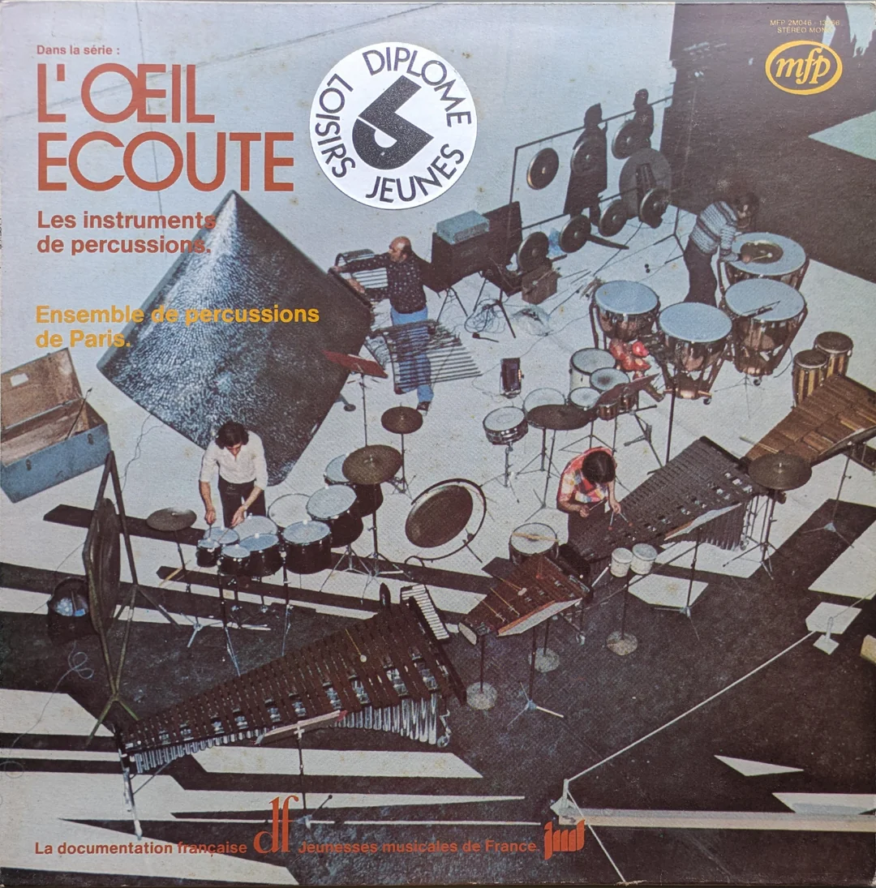
This is a very odd record indeed, when I started looking more deeply in the MFP catalogue this record stuck out like a sore thumb (presumably sore from being whacked by a percussive mallet).

Obviously this is an educational record, a one off for them as far as I am aware. One side is just drum hits. Presumably some Parisian school teacher would sullenly play this out for the class to note how to differentiate percussion instruments? Who knows. In the right hands I imagine it could be sample heaven.

Side 2 is pleasant enough modern classical percussion pieces. The blunderbuss of the MFP A&R department strikes again.

One thing that is very unusual – the last track of side one is a solo recording of the Bronte. This is a one off instrument invented by Vincent Geminiani. It is one of the most unusual sounding percussion instruments, incredibly atmospheric and really eerie. It can be heard in the background of the killer track Ophis Le Serpentaire (not on this record) and it provides an ethereal presence over the whole piece.

The record was produced by Anton Kwiatkowski, prolific at MFP. Another of his albums more widely known is Non-Stop Pepsi Party definitely worth checking out too.

